**Materials:**

Something that will play music and an age-appropriate song to play

**Lesson Plan:**

New vocabulary:

Loop: The action of doing something over and over again

Next, ask for a volunteer and have them stand.

* Instruct your volunteer to walk around the table (or their chair, or a friend).
  + When they finish, instruct them to do it again, using the exact same words you did before.
  + When they finish, instruct again.
  + Then again.
* Would it have been easier for me to just ask you to go around the table four times?
  + What if I wanted you to do it ten times?
* If I want you to repeat an action 10 times, that's called "looping."
* When I know in advance that I want you to do something a certain number of times, it's easier for both of us if I just ask you to "Repeat it that many times."
* Can you think of some other things that we could loop?

Next, get the students on their feet and have them face you. You’re going to use a dance that has repitition to help the students understand loops. You can either invent your own dance or use the one below:

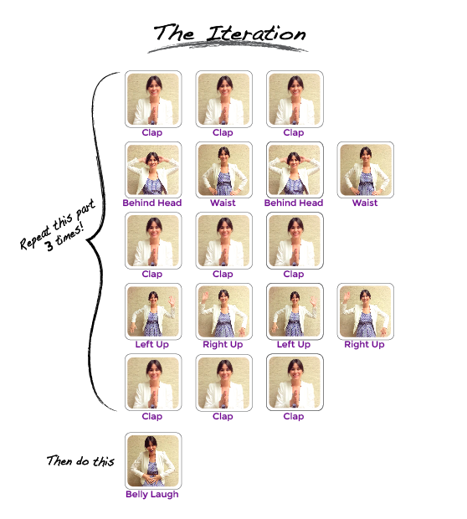

First, show them the dance. Then, give step-by-step instructions and have them do the dance with you. Have them do it all the way through once. Finally, have them sit down and write the instructions. Is there anything they can do to make the instructions simpler? (Hint: instead of writing “clap clap clap”, they could write “clap 3 times.”